Name _____________________________ AP Calculus
Section 6.4 Practice: Separable Differential Equations

Show all your work!
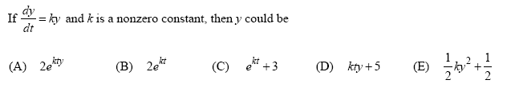
1.

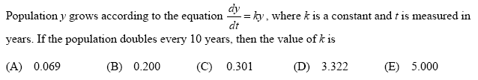
2.

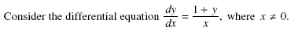
3.

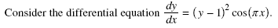
4.

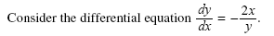
5.

